Year 11 Simple Interest Extension

1)
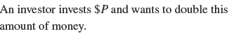
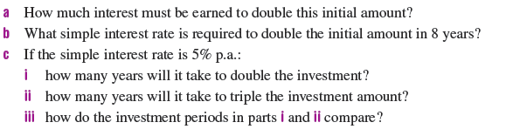

2)
